34.84: a) Treating each of the goblet surfaces as spherical surfaces, we have to pass, from left to right, through four interfaces. For the empty goblet:
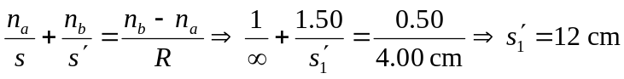
So the image is 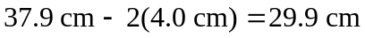to the left of the goblet.
b) For the wine-filled goblet:
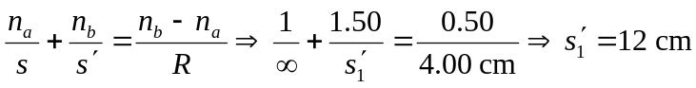
to the right of the goblet.

